# Deployment Checklist for Eforms

1. Hide the language buttons. If not already done, default the radio buttons to one of the languages.
2. Remove any temporary development artifacts (error button).
3. Save the form as a Dynamic pdf form.
4. In the config script object that has the Log_logLevel variable, set the log level to cLog.LEVEL_TRACE.
5. Do a smoke test to ensure there are no lingering JavaScript errors.
6. Change the language and save a copy of the form.
7. Open the form and set the Form Title author, and initial view.
   1. To change the document properties:
      1. bring up the Document Properties (CTRL-D win or CMD-D mac)
      2. Select the Security tab
      3. Change Security Method to Password Security
      4. Click on checkbox for "Require a password to open document"
      5. Type in a password
      6. Click OK, verify the password you just typed and click OK
      7. You might get a dialog box that pops up and says something like "Security settings will not be applied....". Click OK
      8. You should be back at the Security tab and Security Method should say Password Security.
      9. Next to Security Method: Password Security is a button called Change Settings... Click on it.
      10. In the dialog that pops up don't do anything! Just click Cancel.
      11. You should be back in the Security tab.
      12. Change security method to No Security. Click on OK in the verification dialog that pops up.
      13. Click on the very bottom OK button to dismiss the Document Properties dialog.
      14. Reopen the Document Properties dialog and now when you go to the Initial View settings you should be able to set them as they won't be grayed out (assuming all steps followed correctly)
   2. Set the Author to Health Canada or Santé Canada
8. Add reader rights to the form. This will have to be done for the English and French separately.
   1. Save ability
   2. Import/Export of Data
   3. Ability to sign.
   4. Digital signatures. (At least for the eforms project

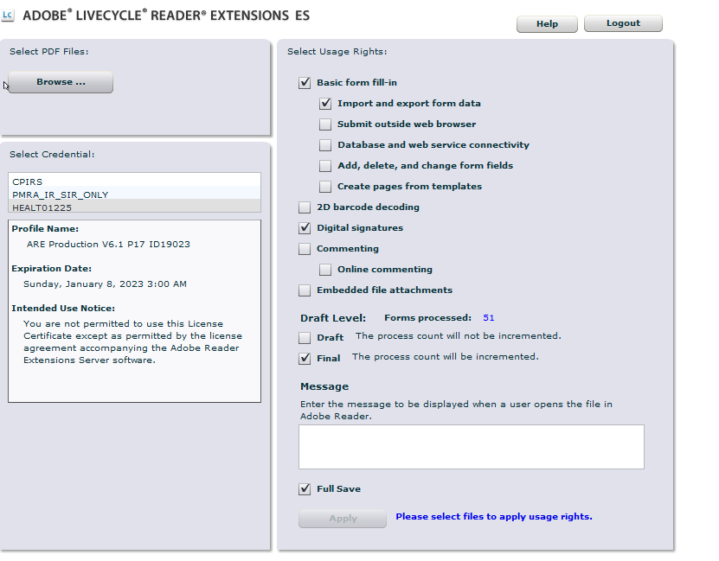

Figure 1: Reader rights to enable